**Union and Draw School**

Comp 3322 - Software Engineering

Final Project Report

**Submitted by**

Ihsan Karagol

Damlanur Onat

Rowshen Paltayew

Bakybek Tazhibaev

Computer Science Department

May 07, 2017

**Table of Contents**

1. **Introduction**
2. **Project Organization**

2.1 Software Process Model

2.2 Roles and Responsibilities

1. **Project Management Plan**

3.1 Tasks

3.2 Assignments

3.3 Timetable

1. **Additional Material**

5.1 Screenshots

INTRODUCTION

We did education website about student life, like which places they are living with, and how students can help according to reach good grades, and school activities and events

1.1.1 Context of the project.

This project related to high school students. And it will help them to improve their success and attend to good universities.

1.1.2 Explain the need and how this project will address it?

People will need this project since it is not so professional website for only adult people, we use curves for div boxes and we use some animation pictures it will help highschool students to understand and not get bored.

2 PROJECT ORGANIZATION

2.1 Software Process Model

 We selected Software **Prototyping Process model** for our website project. It went The advantages of using Prototype model in our project were: We could better understand requirements for user functionality, and interface, since we can actually going into final development stage. It enabled us to add

3 PROJECT MANAGEMENT PLAN

3.1

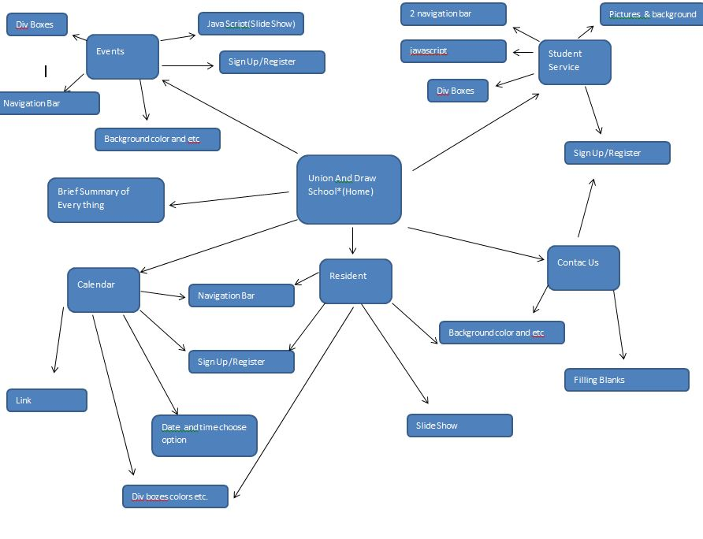

3.2 Assignments

Who worked on which part.

* Ihsan Karagol
  + Home
  + Sign Up
  + Student Service
  + Login/Register
* Damlanur Onat
  + Resident
* Rowshen Paltayew
  + Calendar
* Bakybek Tazhibaev
  + Events

4 TEST

4.1 Features Tested

1. Main Html
2. Logo sizes
3. Website name
4. Student Service
5. Resident
6. Calendar
7. Events
8. Sign Up /Login page
9. Colors and design

5.1 Saved Place for videos and screen shots

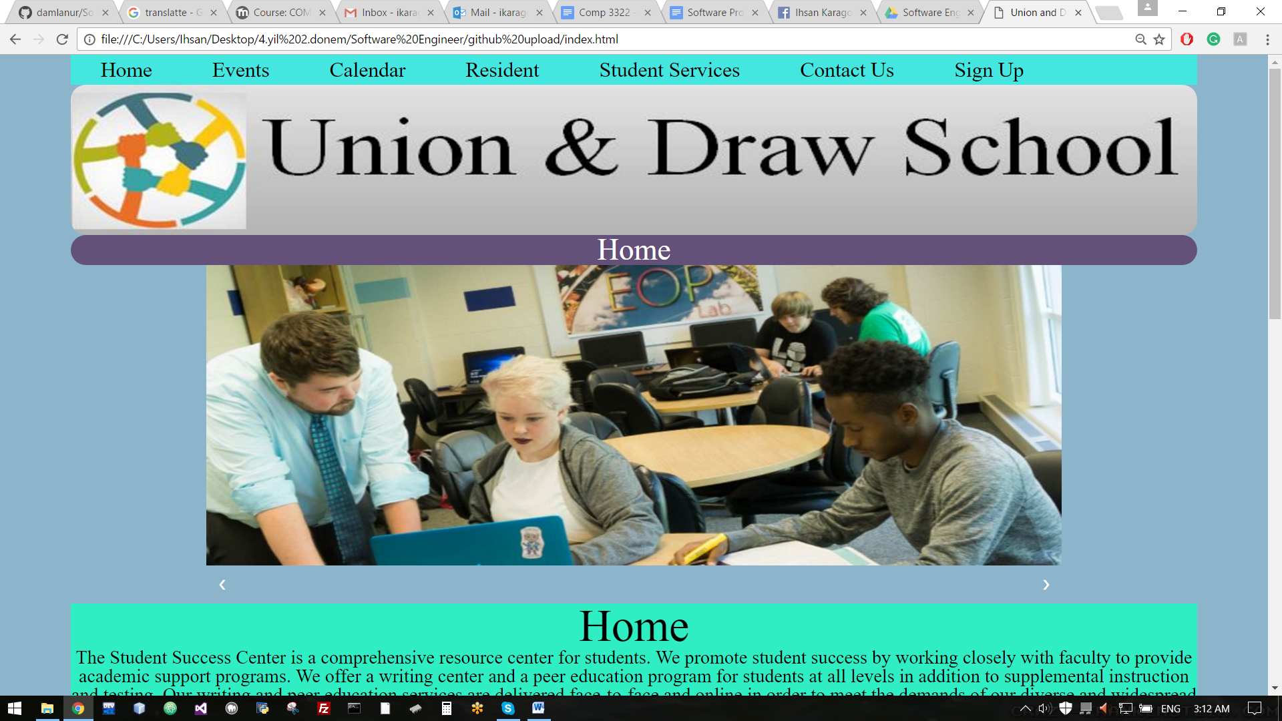 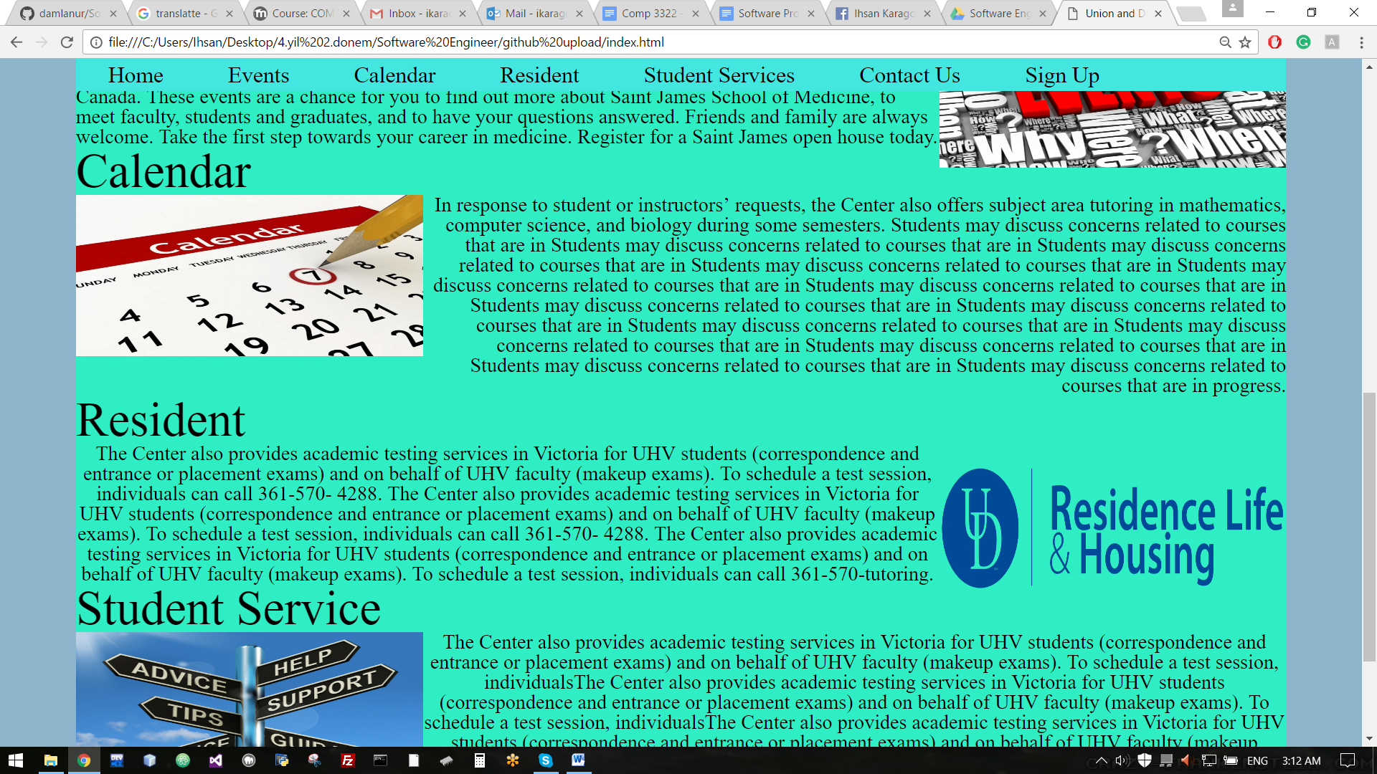 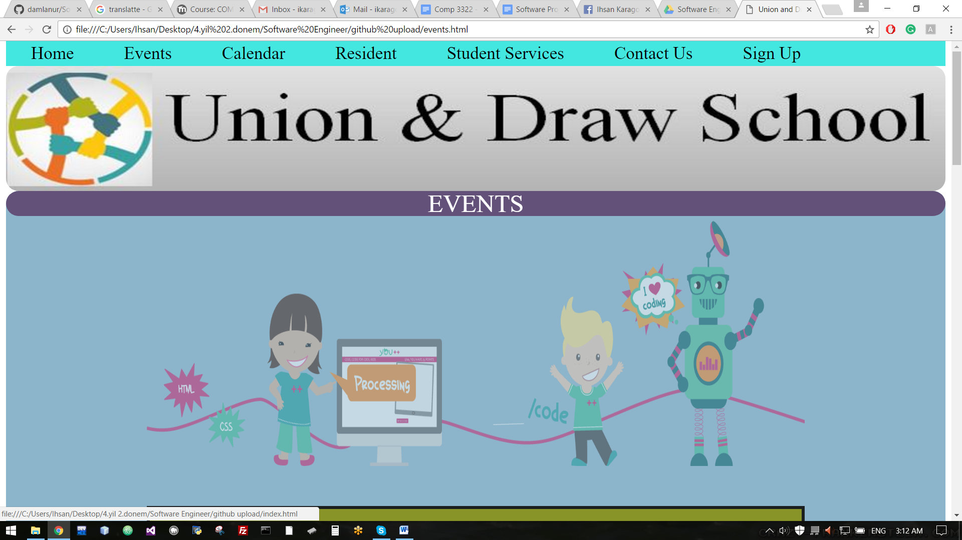 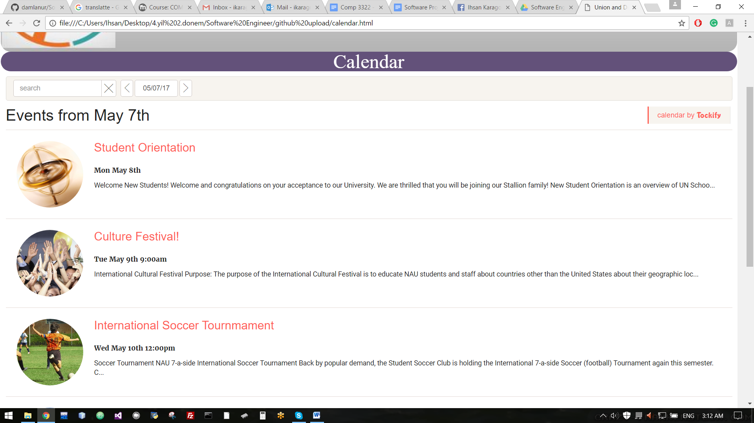 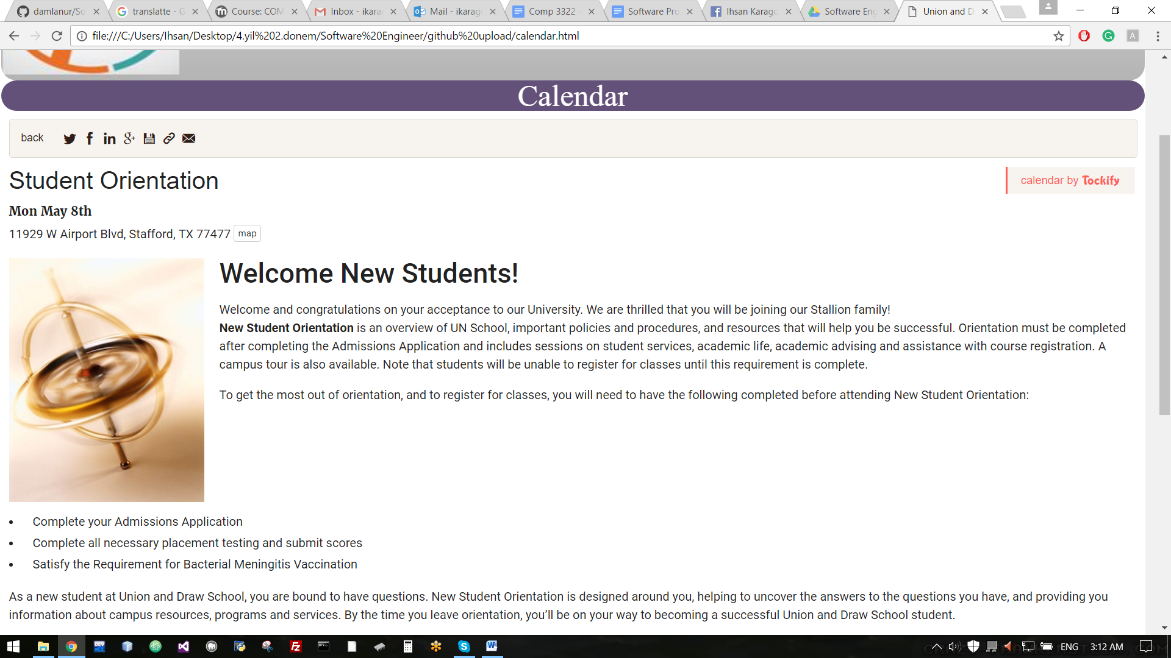 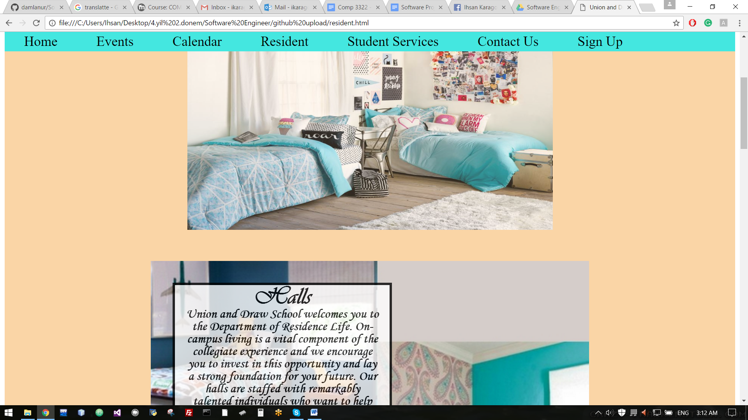 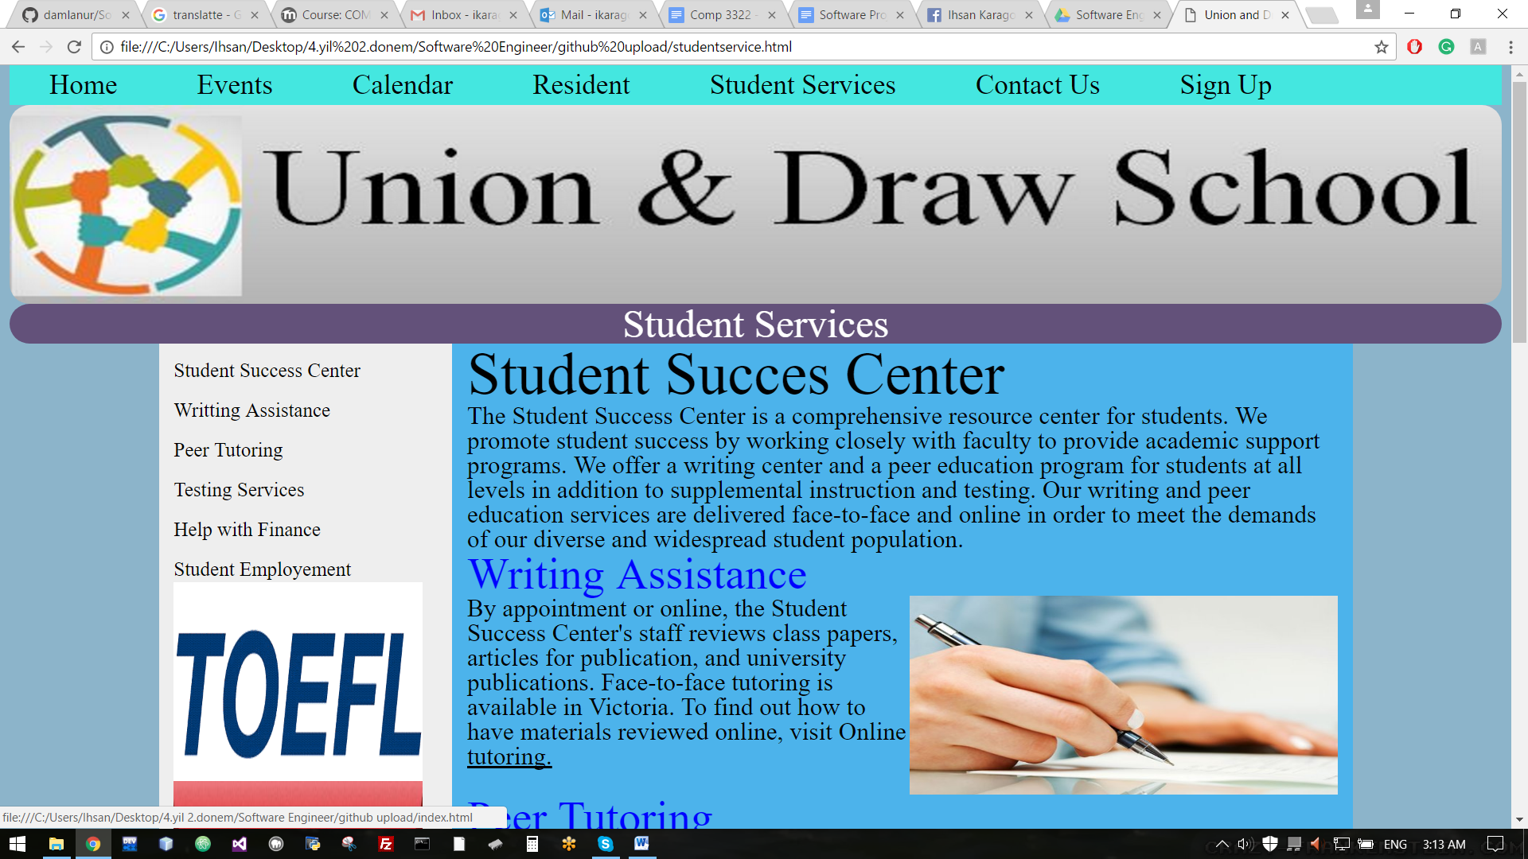 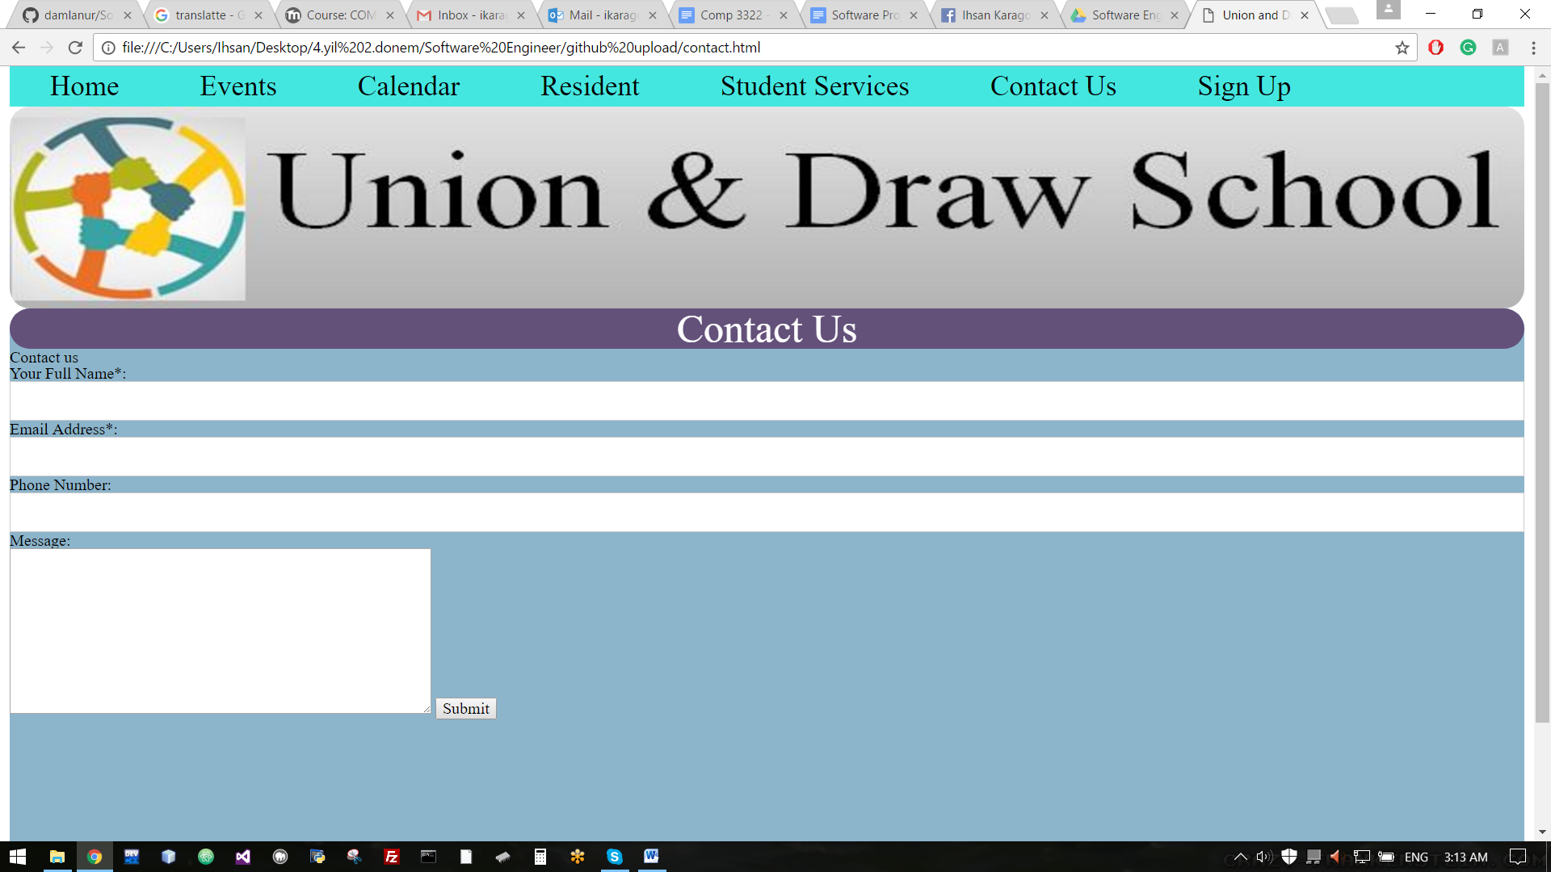 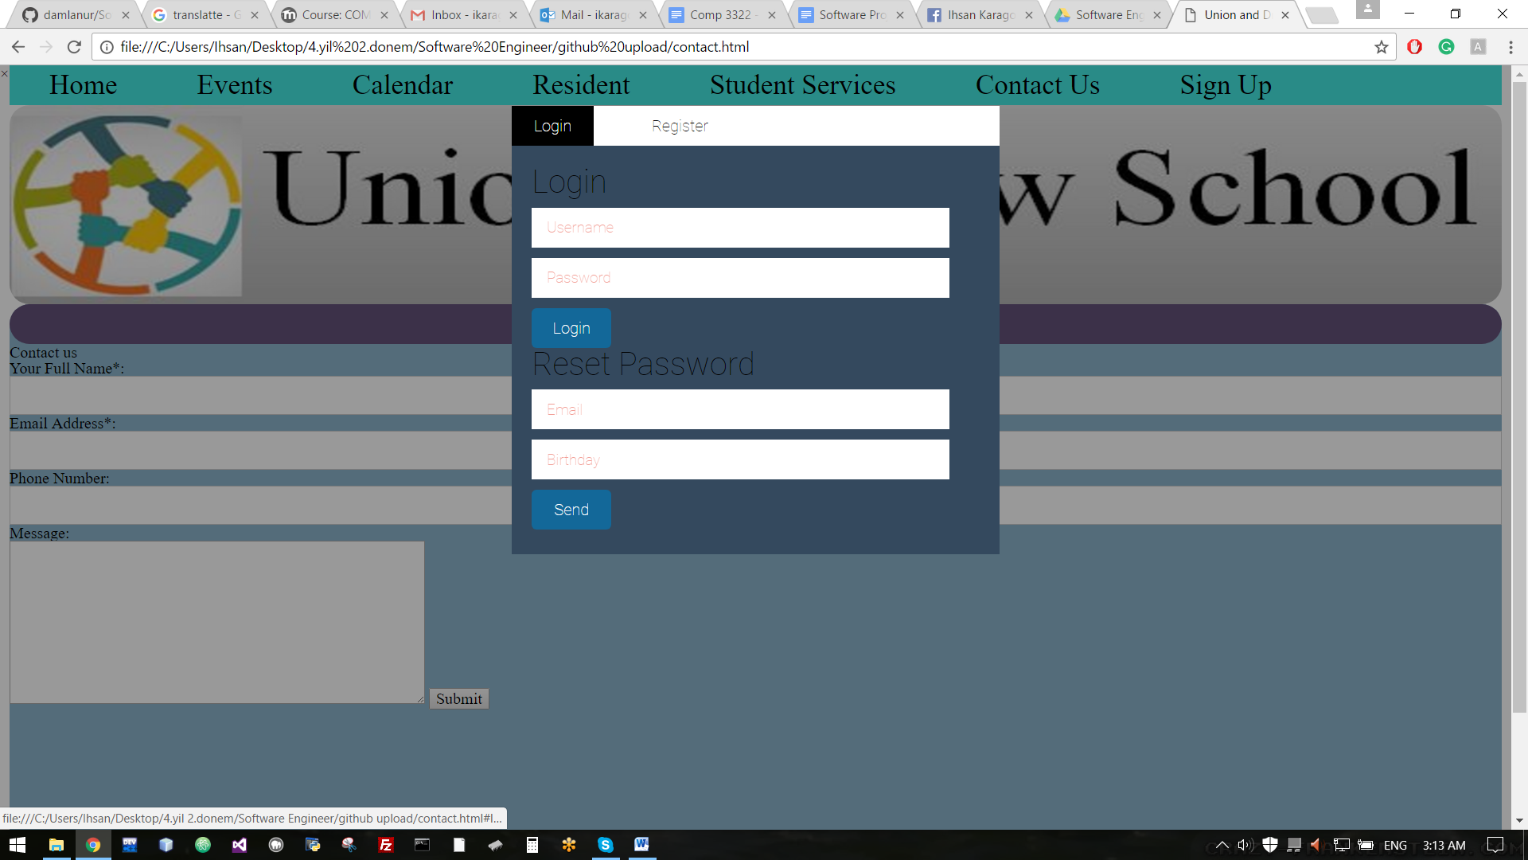 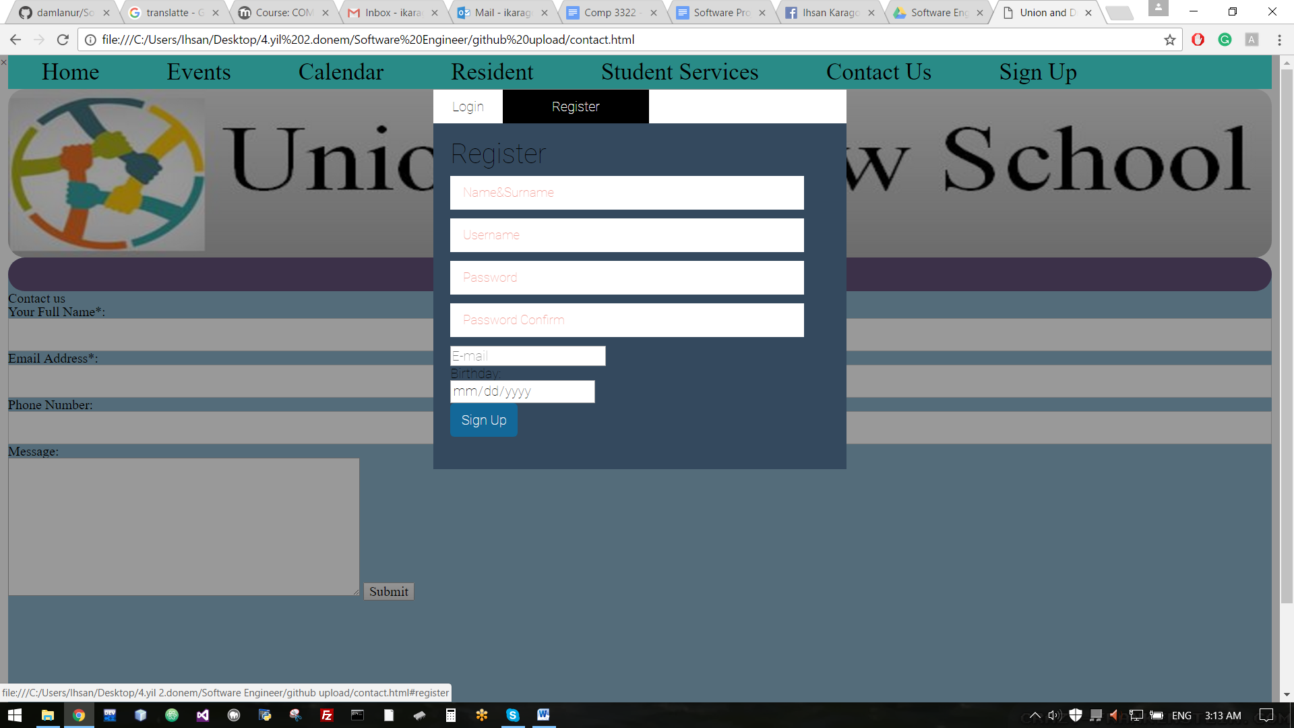

<https://drive.google.com/drive/folders/0B4mSzTZaWzBfTG5xWUplSnE5YnM>

**5.3.1 Repository(Video)**

https://www.dropbox.com/s/xz8klhfzuan2vnc/SE%20fvideo.mp4?dl=0

**5.3.2 Participation**

(add your link that shows contribution of each member)

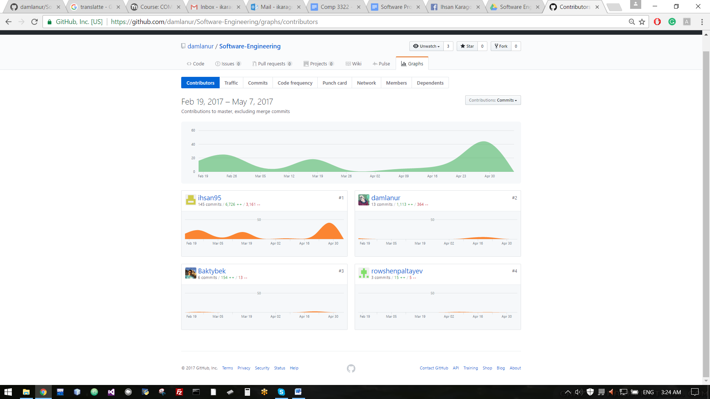

<https://github.com/damlanur/Software-Engineering/graphs/contributors>

Meeting Notes

First Meeting Notes

According to these

Today is Feb 27

1. Until March 2 I will assign Each of us their parts

and Also

I will try to put some videos for what I want for minimum requirements

2. Between March 2 and march 7 We will discuss about what is the minimum requirements for each html parts

Like homepage;

-need navigation

-need map location

-need some vision things

-etc.

(IMPORTANT FOR THIS PART WE DONT NEED TO SPEAK TOO MUCH DETAIL FOR HTML FILES)

3. Between March7 -March 14 I want all of them finish their parts minimum put something that is related

Do it minimum requirement

Speak with group member about if you have questions

4. Between March 14-28 WE WILL WORK ON DETAILS

At this point we have minimum requirement and normally we somehow finish it.

Now we will work details how can we present this is like a professional website

(WE NEED TO SPEAK MORE IN Hangouts or face to face.)

My suggestion is face to face and bring some examples websites)

For example;

- I saw 1 website navigation bar and I like it and I will copy that website link

- Another website I saw the design is good and I copy that website link

-etc.

- At the end everybody will bring some ideas with example websites and we will decided which one is good or bad

5. Between March 28 and April 10 I want to work with Baktybek

Convert this html file to PHP and We will work on Database

6. Between April 10-19

Our group we will speak with Kemal Aydin about website

How it is ?

What is more requirements?

Probably we will not have any problem.

Also I will speak with Ihsan Said about the website how it is what is the requirements?

With Ihsan Said(Advance Web) We may need to put something more?

At this point I want to know new ideas and

help how to connect with database etc.

7. After that we will ready to present our project

Second Meeting Notes

Home= Ihsan Karagol

Events=Baktibek

Calendar=Rowshen

Galeria= Damlanur

-For Home Page(Ihsan)

Why?

You guys already know I am working on Home page

for your parts

Also you guys want me to do that and I believe I can do that

-For Events (Baktibek)

Why?

I believe baktibek knows html and than he can have creative ideas about events

how to organize people. Prepare events etc.

-For Calendar (Rowshen)

Why?

I was hardly choose between Rowshen and Damlanur which one can do?

and after that I see that

Damlanur knows

maybe better than rowshen also I realize that she can also can get help

from her other friends.

For Rowshen I see that

-he may have difficulties to create new ideas because he is working and

have some issues to come together and may have difficulties to find

time to do.

Also at the same time he has to learn how to do his ideas? etc.

- Also I know that he wants this part

that means probably he already some ideas he can do that.

-For Galeria (Damlanur)

Why?

For Characteristics girls have more care about view (vision)

(How beautiful with color and design, or (Uygunluk) )

Also I see that she can get some help from her friends she can find time for

get together with her friends to get help.

Also Damlanur if you cannot do anything for your part you can

find different topic

like:

-Educate(Train) your Child

- How to educate your child

- Different kind of trainings (think like our school clubs)

-Students Financial Problems

-Students success steps

-etc

Just try to find something, that will fit in topic. Also your part will be look

professional

Third Meeting Notes

- How it going on how people html parts, we speak that until march 7 everybody has to put something in their html file

- If anyone need help, he/she can get help from other teamworks.

- Try to bring new ideas according to improve website quality.

- Don’t be stressful relax just follow the syllabus that leader (Ihsan Karagol) is make it up.

- Now nobody has difficulties for their html part.

Fourth Meeting Notes

Meetings

Damlanur= You have to fix your html part to zoom problem make static

Rowshen= you have to add more informations in to your html part

Baktibek= If you can its better to find better html structure for your part

Ihsan= Work on home page, student success part and contact us.

-All of us finish until coming may 1st